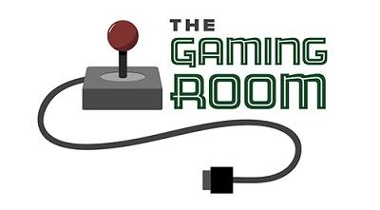

<Name-of-Software-Application>

CS 230 Project Software Design Template
Version 1.0

Table of Contents

CS 230 Project Software Design Template 1
Table of Contents 2
Document Revision History 2
Executive Summary 3
Requirements 3
Design Constraints 3
System Architecture View 3
Domain Model 4
Evaluation 6
Recommendations 8

Document Revision History

Version | Date | Author | Comments
1.0  2.0  3.o | <09/21/25>  <10/04/25>  <10/19/25> | <Ahmed Ahmed> | <project>  <project2>  <final project>

Instructions
Fill in all bracketed information on page one (the cover page), in the Document Revision History table, and below each header. Under each header, remove the bracketed prompt and write your own paragraph response covering the indicated information.

Executive Summary

This software design document presents the proposed solution for developing Draw It or Lose It, a web-based game application for our client, The Gaming Room. Inspired by the classic TV game show Win, Lose, or Draw, the game allows teams to compete by guessing images as they are being drawn. The application will feature a library of stock images used as drawing clues and support multiplayer participation across four rounds of gameplay. By transitioning to a web-based platform, the game will be accessible on a wide range of devices and offer an improved, more interactive user experience. This design is based on the client’s requirements and focuses on delivering an intuitive, engaging, and scalable solution.

Requirements

- Web-Based Platform Accessibility
  - The game must be accessible through a web-based platform and compatible with various devices and operating systems.
- Team Participation
  - Each game should allow one or more teams to participate.
  - Multiple players can be assigned to each team.
- Unique Game and Team Names
  - All game and team names should be unique to avoid conflicts.
  - The application must provide users with the ability to check name availability during team creation.
- Single Instance in Memory
  - The application should ensure only one instance of the game is active in memory at any time.
  - This can be achieved by assigning unique identifiers to games, teams, and players.
- Time Limits for Rounds
  - Each round of the game should have a set time limit, such as one minute per round.
  - Drawings will be progressively revealed over the course of the round, with the full drawing completed at the 30-second mark.
- Team Guessing Rules
  - If a team fails to guess the puzzle within the allotted time, other teams will have the opportunity to guess.
  - Each remaining team has 15 seconds to make one guess in an attempt to solve the puzzle.

Design Constraints

Web-Based Distributed Environment
The game application must be developed for a web-based platform, which brings certain challenges, including network communication, security, and ensuring compatibility across different web browsers and devices.
Unique Name Enforcement
The system must enforce the uniqueness of game, team, and player names to prevent conflicts and ensure a smooth user experience when creating or joining games.
Single Instance Constraint
To maintain proper functionality, the design must ensure that only one instance of the game service is active in memory at any given time.

System Architecture View

Please note: There is nothing required here for these projects, but this section serves as a reminder that describing the system and subsystem architecture present in the application, including physical components or tiers, may be required for other projects. A logical topology of the communication and storage aspects is also necessary to understand the overall architecture and should be provided.

Domain Model

The diagram illustrates the class structure of the Draw It or Lose It game application. At the core is the Entity class, which functions as the base superclass for all entities in the system. It defines shared attributes, such as id and name, ensuring that every entity is uniquely identifiable and named. The Game, Team, and Player classes extend the Entity superclass. These subclasses represent the primary elements of the application: a Game consists of multiple Teams, and each Team is composed of multiple Players.The Game Service class maintains a composition relationship with Game, meaning it manages the lifecycle of game instances and keeps references to multiple game objects. Similarly, Game composes Team, and Team composes Player, reflecting the hierarchical structure of the application.
The Program Driver class contains the main function, serving as the application’s entry point. Here, the singleton instance of Game Service is created, guaranteeing that only one instance exists across the entire program. Through this service, Program Driver handles the addition of games, teams, and players. Additionally, Program Driver depends on the Singleton Tester class, as indicated by the <<uses>> relationship in the diagram.
The UML class diagram highlights several object-oriented programming principles, including inheritance, encapsulation, and abstraction. Inheritance is shown through the relationship between Entity and its subclasses (Game, Team, and Player), allowing shared attributes and behaviours to be reused and reducing code duplication. For instance, subclasses invoke the superclass constructor with the super keyword.
Encapsulation is demonstrated in Game Service, which restricts direct access to its internal state (such as its constructor and list of existing games) while providing controlled methods for interaction. This design ensures data privacy, enforces the singleton constraint, and promotes abstraction. Abstraction is further reflected in how the classes manage games, teams, and players by hiding unnecessary implementation details and focusing only on essential interactions.

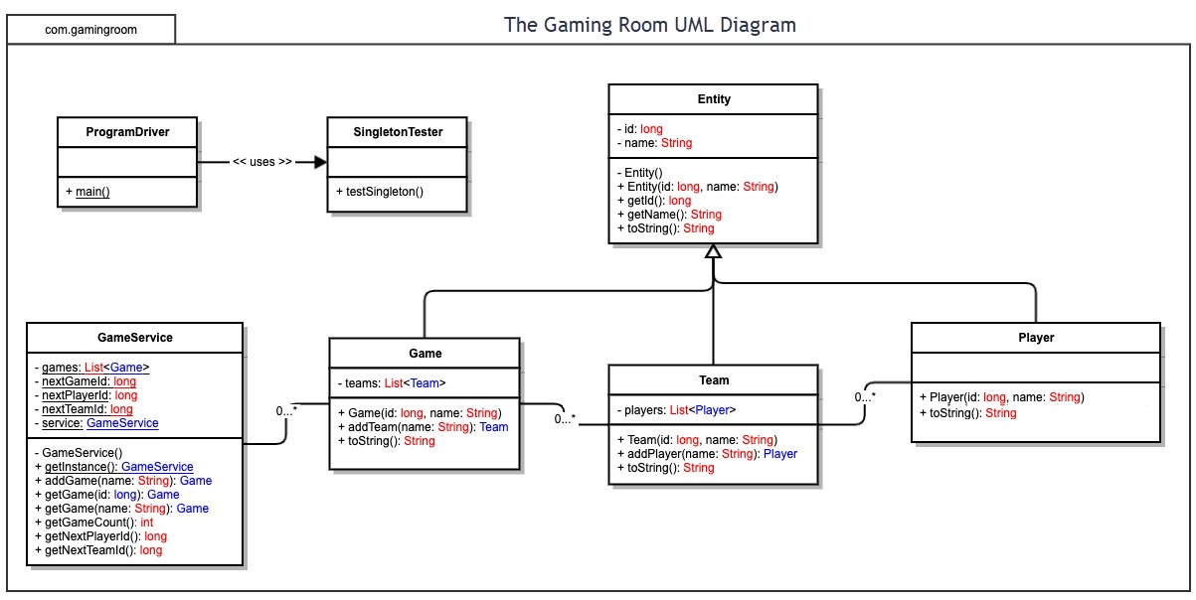

Development Requirements | Mac | Linux | Windows | Mobile Devices
Server Side | OS X Server is available for Mac but unless the client wants to purchase their own hardware finding hosts will be difficult and expensive.  OS X Server is $499 USD for 10-clients. Or, $999 for unlimited. | Linux is the most popular webhosting OS. Because Linux is opensource, maintenance and license costs tend to be cheaper than closed OSes like Windows.  Moreover, typical cloud providers like Google and Amazon offer Linux preferentially over Windows. | Windows servers are nice because they are GUI based and many applications used in the office will also run on the server – so familiarity is abundant.  License costs, typically per user, tend to be very high – especially compared to Linux.  Windows server licenses range from $6,200 (up to 16 core licenses) to $500 (up to 50 clients) per installation per year.  Hosting platforms may be more limited as compared to Linux. | Mobile devices can be used as a personal webserver or file server, but they are not equipped for multi-user serving.  The hardware is typically more limited, e.g., RAM, and they are not scalable like blade servers.  Costs is unknown as the hosting tools would probably need to be designed and built in-house.
Client Side | To develop for Macs, you need a Mac computer running the latest version of XCode.  Moreover, the macOS SDK is in Objective-C or SWIFT which are lesser-known languages.  Lastly, Windows usage is 75% of the market vs. macOS’s 16%. This presents a smaller market opportunity. | Development in Linux should be straightforward as Java or C/C++ or Python could be the language of choice – which are all commonly used.  Moreover, multi-users support is available on the GNU/Linux platform. GNU/Linux development might have little value as there is no widespread use. | Windows is typically developed using C# or .NET which are both common. There would be no barrier to entry to development of a Windows client application.  Windows has been a native multi-user platform since Windows XP.  Windows is the preferred OS for 75% of computer users which makes for a better business case. | Mobile devices are not designed to be multi-user. However, design a client application for Android or iOS is straightforward.  Android SDK is Java based so code developed for Windows and Linux might be able to act as a jumping off point.  iOS is SWIFT based so the same requirements for Mac apply, including the hardware needs.
Development Tools | Mac use Objective-C and SWIFT for development languages.  XCode is the common IDE used for Mac development.  XCode is listed as $99 USD per year per developer. | Linux development may take the form of C/C++, Java, or Python.  Python IDEs are often free, e.g., NotePad++. PyCharm is another popular Python IDE.  C/C++ IDEs are numerous – but not all are available for Linux. Eclipse can do all of these and is free. | Windows is primarily developed using C# and primarily .NET.  Microsoft’s Visual Studio is an immensely popular IDE and offers many plugins and integration options, e.g., Jenkins, TestComplete, etc.  Visual Studio ranges from $45 – $250 USD per user, depending on features, per year. | Android SDK is Java based and the most widely used Android IDE is Android Studio which is developed by Google as the official development tool. Android Studio is free to download.  iOS’s Objective-C and SWIFT languages are almost exclusively developed in XCode.  XCode is listed as $99 USD per year per developer.

Evaluation
There are a few potential targets for development, e.g., Macintosh, Windows, Linux, mobile platforms, for either hosting/serving or acting as the client. The following table discusses the strengths and weakness of each platform.

It should be pointed out that the server and client choices are not linked. That is, if Linux was chosen as the server OS windows may still be the preferred option for the client.

Recommendations
This section analyzes the characteristics and techniques specific to various systems architectures and presents recommendations for The Gaming Room to expand its game, Draw It or Lose It, into additional computing environments. The recommendations address the following key areas: operating platform, operating system architecture, storage management, memory management, distributed systems and networks, and security.

1. Operating Platform
Recommendation:
The recommended operating (server) platform for The Gaming Room is Microsoft Windows Server.
Rationale:
Windows Server provides a stable, scalable, and flexible environment for deploying and managing cross-platform applications. Its compatibility with The Gaming Room’s existing Android-based system ensures seamless integration with current operations. Furthermore, its strong developer support ecosystem and wide range of development frameworks, including .NET Core, Xamarin, and React, make it ideal for building, testing, and deploying web and mobile versions of Draw It or Lose It.
Key Advantages:
- Broad compatibility with web and mobile environments.
- Integration with Android and iOS applications via shared development tools.
- Extensive support for Microsoft’s cloud and virtualization services (Azure, Hyper-V).
- Global developer community and rich documentation.
- Cost-efficient scalability for future expansion.

2. Operating System Architecture
Recommendation:
Use a hybrid operating system architecture, such as that implemented by the Windows NT kernel, which combines features of monolithic, layered, and microkernel designs.
Characteristics and Advantages:
- Layered Management: Improves organization and simplifies maintenance by separating system functions (e.g., user interface, kernel, device drivers).
- Performance Optimization: Retains the speed and direct access benefits of monolithic systems while improving modularity.
- Security and Stability: Provides enhanced protection by isolating critical kernel functions.
- Customizability: Allows for flexible configuration and integration of additional modules or services as needed for Draw It or Lose It.
This architecture will allow The Gaming Room to achieve a balance between performance, reliability, and flexibility as the platform scales across devices and operating systems.

3. Storage Management
Recommendation:
Adopt Microsoft Azure Storage as the primary storage management solution.
Rationale:
Azure integrates seamlessly with Windows Server, providing both cloud-based and on-premises options that can handle large amounts of structured and unstructured data. The service supports high availability, redundancy, and automatic backup, which are critical for continuous game operations and user data management.
Key Features:
- Azure Blob Storage for image and media files (ideal for storing game assets and user-generated content).
- Azure Files for shared access across multiple servers and development environments.
- Scalability: Automatically adjusts to growing storage demands.
- Cost Efficiency: Pay-as-you-go model with flexible scaling.
- Reliability: Built-in replication and failover mechanisms for data protection.
By leveraging Azure Storage, The Gaming Room can ensure that Draw It or Lose It operates efficiently, even as the number of users and stored assets grows.

4. Memory Management
Recommendation:
Leverage Windows Server’s virtual memory management and paging techniques to optimize performance for Draw It or Lose It.
Rationale:
Windows Server uses a combination of physical and virtual memory management to allocate resources efficiently across applications. The system divides address space between user and kernel modes, ensuring stability and protection of critical processes.
Techniques Utilized:
- Demand Paging: Loads program data into memory only when required, reducing initial load time.
- Virtual Address Space: Each process operates in an isolated space, minimizing interference and improving security.
- Paging File Management: Uses disk-based paging files to expand available memory.
- Resource Monitoring: Built-in tools like Task Manager and Performance Monitor help maintain optimal performance.
These methods allow Draw It or Lose It to run smoothly on a variety of devices while efficiently handling game sessions, media, and concurrent users.

5. Distributed Systems and Networks
Recommendation:
Implement a distributed system model using Azure Cloud Services to connect and synchronize Draw It or Lose Itacross platforms.
Rationale:
A distributed architecture enables real-time communication between clients (users on mobile and web platforms) and the server environment. Azure’s distributed networking capabilities—such as App Services, Load Balancers, and Virtual Networks (VNet)—allow the system to scale dynamically and maintain connectivity during high user demand.
Approach:
- Cloud Integration: Host the game logic and database on Azure Cloud for centralized management.
- API-Based Communication: Use RESTful APIs for communication between mobile, web, and server components.
- Load Balancing: Azure Load Balancer ensures uptime and even distribution of traffic.
- Redundancy and Failover: Built-in redundancy minimizes downtime during outages.
By deploying on a distributed system, The Gaming Room can ensure consistent user experiences across devices and maintain reliable system performance under varying network conditions.

6. Security
Recommendation:
Use Azure Security Services and Azure Active Directory (AD) to protect user data and secure communications between platforms.
Rationale:
Security is essential for protecting player data, preventing unauthorized access, and maintaining trust. Azure provides built-in, enterprise-level security solutions that align with best practices for encryption, identity management, and access control.
Security Measures:
- Authentication and Authorization: Implement Azure Active Directory for secure user logins and role-based access.
- Data Encryption: Use SSL/TLS for all data in transit and AES-256 encryption for data at rest.
- Access Controls: Restrict permissions based on the “least privilege” principle, granting users access only as needed.
- Network Security: Use Virtual Private Networks (VPNs) and IP whitelisting for additional protection.
- Threat Monitoring: Utilize Azure Security Center for continuous monitoring and automatic threat detection.
- User Education: Train employees on password and credential management to mitigate human-based security risks.
Through these measures, The Gaming Room can maintain a secure, compliant, and trustworthy environment for all users and developers.

Conclusion
The combined use of Windows Server, hybrid architecture, and Microsoft Azure’s ecosystem offers The Gaming Room a powerful, secure, and scalable solution for expanding Draw It or Lose It into new computing environments. These recommendations ensure operational efficiency, cross-platform compatibility, and long-term sustainability while protecting user information and maintaining performance reliability.

References
Microsoft. (2023). Microsoft Azure Storage documentation. Microsoft. https://azure.microsoft.com/en-us/products/storage/
Microsoft. (2023). Windows Server documentation. Microsoft Learn. https://learn.microsoft.com/en-us/windows-server/
Microsoft. (2023). Azure security and compliance. Microsoft. https://azure.microsoft.com/en-us/overview/security/

